Table Comparing Current Kenai Refuge Regulations with the Proposed Regulations
Courtesy of Alaska Wildlife Alliance
 | Current Regulation | Proposed Regulation | Comments
Trapper Orientation Class | There is a one-time requirement to attend a free Refuge-sponsored Trapper Orientation class in order to obtain a Refuge trapping permit. | None. | This free, easily accessible class decreases the number of non-target wildlife caught; provides information important to managers; addresses public concerns over ethics, safety, and animal suffering; improves trapper understanding of Refuge management objectives  Familiarity with refuge regulations is key to protecting resources and reducing conflicts on this intensively-used refuge. Requiring trappers to attend this course, when compared to the scale of animal suffering that would be mitigated, is extremely reasonable.
Furbearer Conservation Provisions | Several stipulations are in place to help conserve beaver, lynx, marten and red fox on the refuge.  - Beaver are susceptible to overharvest on the Refuge and have been overharvested in the past prior to restrictions. The current permit restricts beaver trapping to one set per beaver lodge in the northern and most accessible portion of the Refuge; trappers are allowed to take only one beaver per lodge in the Swan Lake Canoe System; all beaver lodges being trapped or successfully previously trapped must be marked to alert other trappers.  - Trappers are not allowed to cubby and flag sets (which can be used for other species like wolverines) when the lynx season is closed, as lynx are highly vulnerable to overharvesting when snowshoe hare populations are low.  - American Marten occur at very low densities on the Kenai Peninsula and within the Refuge. Therefore, the current permit stipulates an area closure for marten in unit 15B east of the Kenai River, Skilak Lake, Skilak River, and Skilak Glacier. This area is the only good marten habitat on the refuge. Marten in this area serve as source population for the remainder of the Refuge which could be easily trapped out.  - Red fox are extremely rare on the Refuge; biologists have not seen a red fox on the Refuge for decades there have been no signs that red fox still exist on the Refuge. Therefore, the refuge permit deems that there is no harvestable surplus for red fox and does not permit the trapping of red fox. | No protections. | Refuge purposes do not allow species uncommon on the Refuge, but common elsewhere, to be taken as though they were also common on the Refuge. This is not only a mandated legal purpose of the Refuge, but also a good long-term strategy to ensure diversity of species over space.
Trapper Reporting | Trappers must seal* all trapped lynx, river otter, wolves, wolverine, beaver, and marten.  Trappers must also submit a 1 page Harvest Report no later than June 15. This simple report documents trapper information regarding catch of lynx, river otter, wolves, wolverine, beaver, marten, coyote, fox, weasel/ermine, mink, and muskrat. Trappers must also report all tags and radio collars taken from furbearers within three days and return then within five days to the Refuge. | Only the following species are sealed: lynx, river otter, wolves, wolverine, beaver, and marten. | The information gathered by the current Harvest Report is needed to determine distribution of furbearers on the Refuge, areas important to furbearers, and areas of intense and/or light trapping pressure. These data provide a background and historical context for the harvest of furbearing animals on the refuge over time. They are the only source of harvest data Refuge managers have on coyote, fox, weasel, ermine, mink, or muskrat on the Refuge. Without this reporting, Refuge managers will not have the data they need to manage to their conservation mandates.
Trap Safety Buffers | In addition to the Skilak Loop Wildlife Management Area, trapping is prohibited within one mile of public roads, campgrounds, road accessible trailheads, and within the Skilak Wildlife Recreation Area (including the Kenai River within this area) and Headquarters area (see map). However, trapping for mink and muskrat using leg hold traps 1 1/2 or smaller and 110 or 120 conibears are allowed in these areas outside of the Skilak Wildlife Recreation Area and Headquarters area.  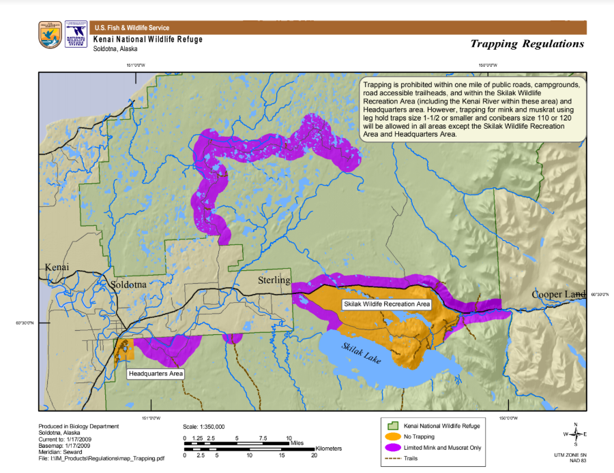 | Only Skilak Loop Wildlife Management Area closed to trapping. | The accidental catch of dogs was a major local concern prior to the late 1980s when the Refuge completed its furbearer management plan and instituted the current requirements, including a closed area buffering trail-heads, facilities, and roads. Since then, the incidental catch of pets declined precipitously. Without these restrictions, the incidental catch of pets will rise.  The area closure around the Refuge Headquarters and Visitors Center improves visitor safety and reduces user conflicts. This area receives high use throughout winter for skiing, snowshoeing, and for refuge-sponsored environmental education, special events, etc. While dogs are not permitted on the refuge trails in this area, many people walk their dogs on Ski Hill Road (main entrance road to Visitor Center and HQ) and dogs will be allowed on the new Refuge trail currently being constructed adjacent to the road (scheduled to open fall 2020). Thus, if this buffer is removed, both pets and people are at risk.  Area closures increase viewing and photography opportunities. These are 2 of the 6 recreational activities mandated by law to receive priority in public use management on all national wildlife refuges.  If the permit is revoked, trapping would be permitted at approximately 29 trailheads (the gateways to over 250 miles of trails), 13 campgrounds, and along all access roads.
Conditions to minimize take of non-targeted wildlife | Traps and snares are prohibited within 30 feet of sight-exposed baits. Cubby and flag sets are prohibited at all times that the lynx season is closed in order to reduce incidental take of this species.  Additionally, all beaver traps and snares must be submerged between October 15 to November 9 and April 1 to April 30. | All beaver traps and snares must be submerged between October 15 to November 9 and April 1 to April 30. | Sight-exposed bait requirements have been known to reduce the incidental take of scavenging birds – eagles, ravens, crows and magpies are the most susceptible to traps and snares set around bait that is visible to them. Without these restrictions, trappers can lay traps on top of bait, which increases incidental catch of non-target species. Trapping will be less targeted and more destructive.
Trap Checking | All leghold traps must be checked at least once every four days in the GMU 15A and GMU 15B (West) portions of the Refuge and checked at least once every seven days throughout the remainder of the Refuge. Body-grip (Conibear-style) traps and drowning sets must be checked at least once every seven days throughout the Refuge.  The trap-check requirement for GMU 15A and 15B was instituted because those areas are most easily accessed (over 60 miles of roads and the most trail access on the Refuge) and most heavily trapped. The Refuge regularly issues over 100 trapping permits per year, and over 70% of permitted trappers trap in 15A and 15B. | No requirements. | - The current trap-check requirement increases potential for the safe release of non-target animals accidentally caught in traps or snares, including bald eagles, ravens, moose and furbearer species for which the trapping season is closed. The 4-day trap check requirement is in place in the most heavily trapped part of the refuge, where there is the highest potential for incidental take of non-target species.  - The current trap-check requirements for leg hold traps also address, in part, humane issues with trapping, as the requirement reduces the amount of time animals spend in traps before being killed. While this is less of an issue with snares, which typically kill quickly, some snare captures also do not immediately kill animals.  - Trap-check requirements reduce potential for waste of trapped animals by decreasing possibility of damage to pelts from scavenging, freezing and thawing, etc. Potential for damage increases the longer trapped animals are not retrieved.
Trapper accountability | All traps and snares must have an attached tag identifying the permittee. Permittees can use a specific identifier such as a mark, symbol, or letters rather than name, to maintain field anonymity, which is provided to the refuge. | No requirements. | The current trap-tagging requirement reduces conflicts between trappers and other users, and increases overall accountability among trappers. Compliance with this requirement is very simple, and similar trap-tag requirements are in place in Southeast Alaska (GMU 1-5) and some Interior game management units.  Trap-tagging reduces the incidences of traps left out after the season. Leghold and body gripping traps left out in the field can remain operable and capable of killing animals for years, and snares for even longer. When traps can be traced to an individual, the trapper has a much higher incentive to ensure all their traps are removed after the season.  Without trapper identification, law enforcement has almost no way to hold trappers accountable or bring poaching charges to court.
Types of Traps | Steel leghold traps having teeth, spiked, or serrated jaws (either attached or as a part of the trap) are prohibited.  Trappers also may not use a conventional steel trap with an inside jaw spread over 9 inches. Exceptions: Killer-style (body-grip) trap with a jaw spread of less than 13 inches | Trappers may not use a conventional steel trap with an inside jaw spread over 9 inches. Exceptions: Killer-style (body-grip) trap with a jaw spread of less than 13 inches may be used. | This is for humane reasons. Legholds used on the refuge are toothless, increasing the likelihood that nontarget species (e.g., dogs) can be released without significant injury
Brown Bear Baiting | Hunting brown bears over bait is not permitted. Brown bear hunting (not over bait) is permitted in designated seasons. | In addition to the existing brown bear hunt, allow for the harvest of brown bears over bait. | See brown bear baiting fact sheet below.
Firearms Discharge | Year-round prohibition of firearm use within ¼ mile of the Kenai and Russian Rivers, designated public campgrounds, trailheads, waysides, buildings, and the Sterling Highway, specifically for the purposes of providing public safety.  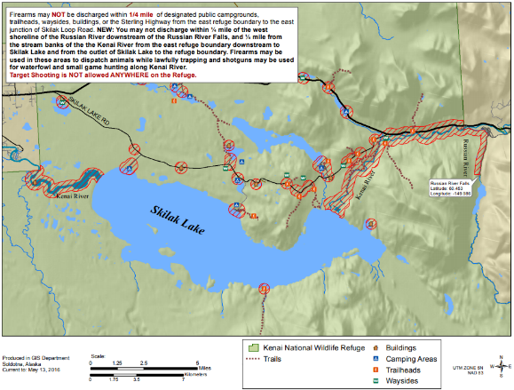 | Only have the current firearm discharge restrictions from May 1- October 31. | If you are recreating (e.g., hiking, bicycling, rafting, etc.) in or near these areas from November 1 to April 30, you will be overlapping with hunters in a firearm discharge area, and thus may:  - Have to listen to the sounds of gunshots while recreating;  - See less wildlife because they are being scared away by hunters and gunshots;  - Witness wildlife being shot, potentially multiple times, while hunted;  - Be at personal risk for accidentally getting shot yourself if you are in the wrong place at the wrong time, especially if there is a stray shot.  The firearm discharge restrictions are in place to increase safety in this highly popular area for boating, hiking, fishing, and wildlife watching.
Bicycle and Game Cart Use | Bicycles are allowed on roads open to public vehicular traffic and game cart use would continue on primary industrial roads in the Swanson River and Beaver Creek oil and gas fields and on the Mystery Creek Road/Enstar pipeline right-of-way. | Bicycles would be permitted on certain designated trails, roads, and right-of-ways totaling 137 miles of new routes: Mystery Creek Road and Enstar Pipeline right-of-way (to the Big Indian public use cabin), Wolf Lake Road, Moose Research Center Road, Marsh Lake Trail (Skilak Wildlife Recreation Area), Ski Hill Trail (to be constructed in 2020), Wood Cut Road. In addition, bicycles may be used on certain lakes when ice conditions allow: Bottenintnin Lake, Kelly Lake, Petersen Lake, Marsh Lake, Engineer Lake, and Hidden Lake.  Use of game carts would be expanded to include allowing use on additional utility right-of-ways, as well as the Moose Research Center and Wood Cut roads. | 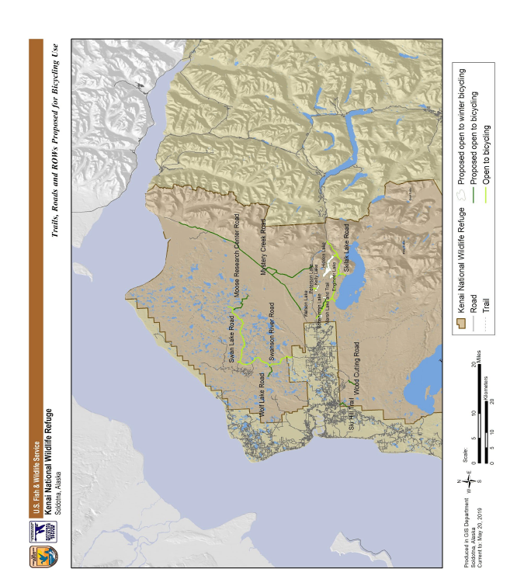
Motorized Vehicle Access | Limited to licensed highway vehicles and snow machines when snow conditions allow (only upon announcement by the Refuge Manager). | Access to designated lakes for ice fishing would be expanded to include use of ATVs, UTVs and snow machines (not requiring announcement by Refuge Manager) in addition to licensed highway vehicles. | Increased motorized use on these lakes would increase temporary disturbance and displacement of wildlife but such impacts are expected to be minor and short in duration, and to not have population level impacts. No impacts to Refuge habitats are expected to occur.

