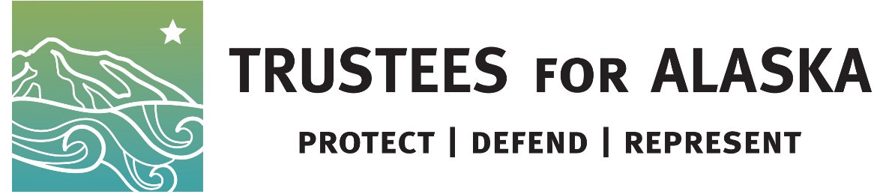

FOR IMMEDIATE RELEASE

DATE

Contacts:

David Raskin, president of Friends of Alaska National Wildlife Refuges, davidc.raskin@me.com, 425-209-9009

Patrick Lavin, Senior Alaska Representative, Defenders of Wildlife, plavin@defenders.com, 907-276-9410

Tim Woody, Alaska Communications Manager, The Wilderness Society, tim_woody@tws.org, 907-223-2443

Dawnell Smith, communications director, Trustees for Alaska,
dsmith@trustees.org, 907-433-2013

Court ruling lets Interior give away public land with stroke of a pen
Groups blast decision allowing Interior’s backdoor land deal with King Cove to move forward

A federal District Court decision today allows a land deal between the Interior Department and the King Cove Corporation to move forward, despite it skirting laws put in place to protect wildlife refuges and designated wilderness. The land exchange aims to pave the way for a road in Izembek National Wildlife Refuge.
“The Federal Court’s failure to halt the planned desecration of the Izembek Refuge Wilderness and wildlife allows Interior to continue its aggressive policy of giving away public lands to serve special interests at the expense of the American people,” said David C. Raskin, president of Friends of Alaska National Wildlife Refuges. “We are disappointed that this decision allows the continuation of illegal and unethical efforts of the current administration to circumvent decades of legislation and regulations enacted to protect public lands and natural areas from destructive developments and preserve them for the benefit of all Americans. We will use every means at our disposal to continue the fight to save the Izembek Refuge.”
Trustees for Alaska filed the lawsuit in January on behalf of nine clients. The suit claims that Interior cannot use the land exchange provision of the Alaska National Interest Lands Conservation Act to gut a Wildlife Refuge and Congressionally designated wilderness, circumvent public process, environmental review, and congressional approval.
“The Court’s decision essentially gives agencies the go-ahead to give away our public lands with a stroke of a pen,” said Katie Strong, senior staff attorney with Trustees for Alaska. “Interior circumvented the law to benefit private interests while gutting the purpose of the Refuge System itself. You can bet we’ll look at every legal avenue for stopping the degradation of public lands.”
The exchange agreement trades Refuge and Wilderness lands to make way for a road without using procedures established by Congress in ANILCA. Various private and commercial interests have advocated for a road over several decades.
The Court found that ….

GROUP STATEMENTS:

“The Court has failed to see the Trump administration’s sleight of hand in trading away the globally-renowned wildlife habitat and Congressionally-designated wilderness lands of the Izembek National Wildlife Refuge,” said Patrick Lavin, senior Alaska representative for Defenders of Wildlife. “We will not let the administration disregard the rule of law and disrespect our public lands.”

“The wilderness values of the Izembek Wildlife Refuge are irreplaceable, and circumventing a public process to build a road right through its heart is characteristic of this administration’s constant catering to private or commercial interests.” said Kristen Miller, Conservation Director at Alaska Wilderness League. “Building it is not in the public’s best interest when there are other, safer options available. It’s a bad deal for taxpayers and it’s a bad deal for the environment.”

“We are disappointed by the court’s ruling and intend to continue to work to ensure that Izembek’s globally significant resources remain protected,” said David Krause, public lands conservation specialist at The Wilderness Society. “The Trump administration plans to gut congressionally designated wilderness and a premier national wildlife refuge by transferring ownership of public lands to private interests, and we intend to fight this land exchange and make certain that the American public’s best interests ultimately prevail.”

“Today’s court decision is an alarming setback for land conservation in Alaska. It gives the administration the green light to transfer public lands into private hands without public process or environmental review,” said Sarah Greenberger, Senior Vice President, Conservation Policy at National Audubon Society. “Paving the way for a road through Izembek National Wildlife Refuge would put significant bird populations at risk, particularly the Pacific Brant. Nearly every single one of these birds stops over in this refuge during migration each year. Audubon will not stop fighting to protect this globally-significant habitat.”

"It's clear that the Department of the Interior ignored the laws in pushing this deal forward, and we're disappointed that the court will not hold them accountable," said Alli Harvey, Senior Campaign Representative with the Sierra Club's Our Wild America campaign. "This land swap and road through Izembek National Wildlife Refuge would be a costly and ineffective use of taxpayer dollars, and would severely damage this important wilderness. We will continue to pursue all legal options to protect our public lands."

"Regrettably the District Court failed to recognize the primacy of ANILCA which codifies that Izembek--like all of Alaska's 16 national wildlife refuges--are ‘National Interest Lands’ belonging to all Americans, not just the residents of Alaska,” said Geoffrey Haskett, President of the National Wildlife Refuge Association. "A part of Americans' conservation inheritance was lost today as an antagonistic administration abetted by a complicit congress continues to favor special interests over our national interest.

